Beautiful Blueberries are making their show at [Lake of the Woods](https://lakeofthewoodsmn.com). They are ripening fast and are in abundance as reported to this writer recently.  Sounds like the berries are at their peak. Lake of the Woods is known for its vast amount of this natural berry that is not only beautiful but delicious beyond measure.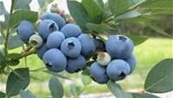

Where do I find these beautiful blueberries? Well, we’ll have to list quite a few areas. A park area along Hwy 11 between Baudette and Warroad is actually named Blueberry Hill. People camp there and also pick these beautiful berries. Another area is south or Baudette in the [Beltrami Forest Area](https://files.dnr.state.mn.us/maps/state_forests/sft00005.pdf) also known by the Faunce Tower area. This natural habitat is known or its beautiful pines and roads through what once was the pioneer area of [Lake of the Woods County. Homesteaders](http://www.lowhistoricalsociety.com) there must have really enjoyed the abundance of food found throughout that land and harvested many many berries.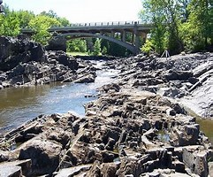

People come from far and wide to harvest these natural blueberries. They arrive with buckets for the harvest and leave with those buckets full. If you’re one of these visitors, be sure to also bring mosquito spray and dress to keep those insects off of you. There’s another species that also enjoys these berries and that is the black bear. It’s wise to keep on the lookout for these creatures as they enjoy the harvest as well.

A one-gallon ice cream pail with a handle works well to hold the fruit. You can set it on the ground and drop berries into it as you pick, and unlike a plastic bag, it won't snag on sticks and thorns as you walk. Hiking boots are great for rough or steep areas. Lighter footwear is fine for easy hikes, but don't be tempted to wear sandals, which don't offer enough foot protection. Long-sleeved shirts and pants are recommended to avoid scratches, scrapes, and mosquitoes; I also carry insect repellent and drinking water, particularly in warm weather.

[Blueberry shrubs](https://www.dnr.state.mn.us/mcvmagazine/issues/2019/jul-aug/berries.html) are 1 to 2½ feet tall and often grow in colonies. Leaves are shaped like an elongated football, typically 1 to 1½ inches long; they grow alternately on greenish-brown branches. Common lowbush blueberries have smooth leaves with fine teeth along the edges, while leaves of velvet-leaf blueberries are hairy and 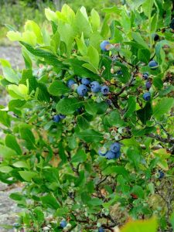toothless. Fruits of both grow in clusters from branch tips. Underripe berries are green, becoming pinkish before ripening to deep blue with a whitish bloom; ripe berries look just like supermarket blueberries but are smaller—typically ¼ to 1/3 inch across. A key ID feature is the short five-pointed crown that is present on the top.

Ripe berries detach easily from the bush. Although you can use opened fingers to comb through a cluster of blueberries, you'll get less debris if you pluck individual fruits. Velvet-leaf blueberries are tarter than common lowbush blueberries, which are also called sweet lowbush blueberries. Both can be used like domestic blueberries, but because they're so small they pack together more closely—so you can use a smaller measure of wild blueberries in muffins or similar recipes. Wild blueberries make outstanding jam and pie.

Another area to explore for these beautiful blueberries is Zippel State Park. This beautiful park has been kept to its natural beauty and as you travel the paths, you can find bushes and bushes of berries to enjoy picking from. While you’re there, enjoy the vast sandy beach and beautiful waters of Lake of the Woods where you can walk out in shallow water for many yards.

Be sure to add this Blueberry adventure to your list of great things to do while visiting Lake of the Woods. Send dad out fishing and let the ladies bring in the bountiful berries for a great eating treat.

For more information contact: [www.lakeofthewoodsmn.com](https://lakeofthewoodsmn.com) and click on the lodging page for great places to stay. Come soon!